**North Forsyth High School Bass Team**

***Please fill out the information required below and return this form to Coach Scott Beard at NFHS.***

**THE NORTH FORSYTH BASS TEAM IS OFFERING SPACE ON THEIR TOURNAMENT JERSEY’S FOR THE 2015 AND 2016 SEASONS:**

* Members will wear jerseys at all team functions including: tournaments, community service projects, and meetings.
* This will be the only fundraiser for the Bass team this year and all funds will go to support the team, travel expenses, and entry fees.

Contact Name:

Company Name:

Address:

City:

State: Zip Code:

Phone:

Email:

* ***Company will provide artwork (please forward to Coach Beard’s email or send with team member)***
* ***Artwork must be in a jpeg format (.jpg)***
* ***Locations will be assigned on a first come first choice basis. If your location choice is not available your ad will be place as close to your desired location as possible.***
* ***In order to have the jerseys for next season all artwork must be turned into Coach Beard by September 11th 2015 – Artwork not received by the deadline will not be on the jersey***
* ***No refunds***
* ***Location preferences will be given on a first come first serve basis***
* ***Sponsor packages- Location and sizes (Sizes are Approximate) Circle One:***

|  |  |  |  |
| --- | --- | --- | --- |
| **RAIDER PACKAGE $400** | **BLACK PACKAGE $275** | **SILVER PACKAGE $225** | **PURPLE PACKAGE $150** |
| * Large front jersey location approx. 12”X6” * Name and logo on the North Forsyth Bass Team website | * Large back jersey location – Approx. 8”X6” * Name and logo on the North Forsyth Bass Team website | * Small back or sleeve jersey location – Approx. 4”X2” * Name and logo on the North Forsyth Bass Team website | * Help a student grow and develop from Bass fishing * Name and logo on the North Forsyth Bass Team website |

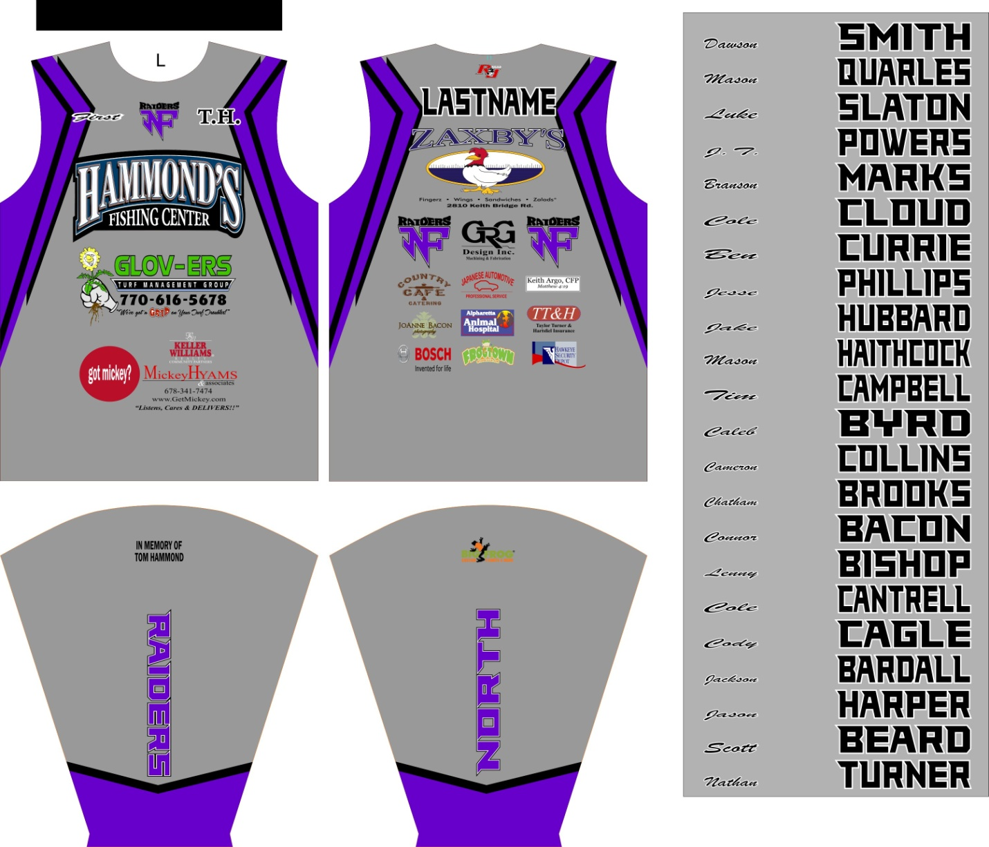

Approx size of Silver package logos

This is a Sample of how the jerseys will look and possible locations. Silver logos maybe on the shoulders or sleeves.

Approx size of Black package logos

Approx size of logos with the Raider Package

North Forsyth High School Bass Team

Coach Scott Beard

3635 Coal Mountain Dr.

Cumming, GA 30028

sbeard@forsyth.k12.ga.us

714-814-5803

Make checks to: North Forsyth High School